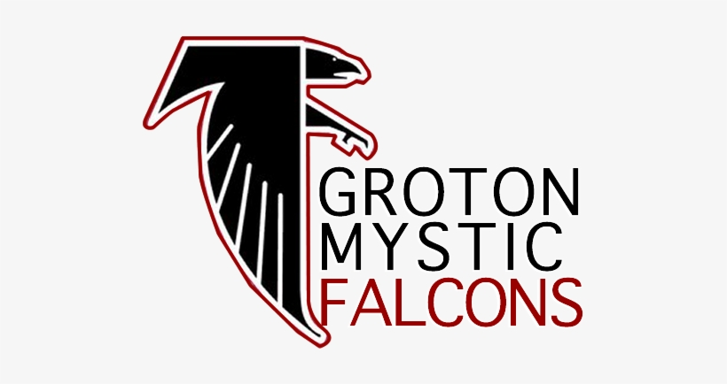  Groton Mystic Falcons  Head Coach Application 2023 | Thank you for your interest in the Head Coach position within the Groton Mystic Falcons League staff. Please consider and answer all questions to the best of your ability. Also included within the application packet is the Background Check Authorization and Coaches Code of Conduct. All must be completed and returned by the January 12, 2023 deadline. You may email the completed packet to grotonmysticfalcons@gmail.com or return in-person at the League Meeting held on January 12th. Should you have any questions, please reach out to the above email. Thank you.

Groton Mystic Falcons Youth Football League PO Box 760
Groton, CT 06340 www.grotonmysticfalcons.com

Head Coaching Application 2023

Name: __________________________________________Team Desired: ________________

Address: _____________________________________________________________________

City: ___________________________________ State: __________ Zip: _________________

Phone: _________________________________ Email: _______________________________

Please describe your personal experience in football/cheer, including number of years & participation level: _____________________________________________________________________________

_____________________________________________________________________________

_____________________________________________________________________________

_____________________________________________________________________________

_____________________________________________________________________________

_____________________________________________________________________________

_____________________________________________________________________________

Explain why you want to be a head football/cheer coach for GMF: _____________________________________________________________________________

_____________________________________________________________________________

_____________________________________________________________________________

_____________________________________________________________________________

_____________________________________________________________________________

The vision of GMF is to consider the whole of the athlete. We aim to not only build skills and technique, additionally sportsmanship and self-esteem. How does your coaching philosophy strive to nurture a wholesome athlete?
_____________________________________________________________________________
__________________________________________________________________________________________________________________________________________________________
__________________________________________________________________________________________________________________________________________________________
In reality, the position of Head Coach requires between fifteen and twenty hours weekly including practice and games. Would you be able to commit to this position, fully, to ensure consistency and stability within your coaching staff and team?

_____________________________________________________________________________

_____________________________________________________________________________

_____________________________________________________________________________

_____________________________________________________________________________

_____________________________________________________________________________

Please provide any other qualifications or certifications you would like us to consider: _____________________________________________________________________________

_____________________________________________________________________________

_____________________________________________________________________________

Please identify two (2) strengths that you would bring to the head coaching position and a weakness that you would need to strengthen:

_____________________________________________________________________________

_____________________________________________________________________________

_____________________________________________________________________________

_____________________________________________________________________________

_____________________________________________________________________________

_____________________________________________________________________________

In the last year, what is one valuable lesson that you have learned from coaching, work or in general, and how would you plan to incorporate that lesson learned in your role as a head coach?
_________________________________________________________________________________________________________________________________________________________________________________________________________________________________________________________________________________________________________________________________________________________________________________________________
Have you ever been convicted of a crime involving a child? Yes No
If yes, please explain: (Please know you must consent to a background check for consideration)
_____________________________________________________________________________

_____________________________________________________________________________

Attached is the Coaches Code of Conduct. Please review and state if you would, or would not,
be able to agree to the terms of the conduct requirements.
____________________________________________________________________________
____________________________________________________________________________

List two (2) personal references (include name, relationship & phone number):

Name/ Relationship

__________________________________________

__________________________________________
Phone Number

_______________________

_______________________

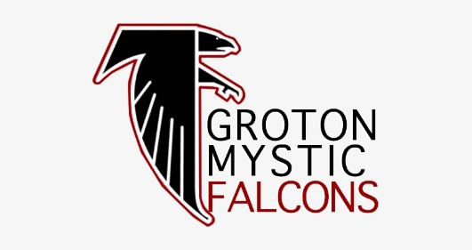

DISCLOSURE REGARDING BACKGROUND INVESTIGATION ON YOU
Groton Mystic Falcons ____________ (“the Company”) may obtain “consumer reports” about you from a consumer reporting agency for employment purposes. A “consumer report” is a background screening report that may contain information regarding your criminal history, sex offender registry status, credit history, employment history, education history, social media activity, driving history, drug testing results, professional licenses, and other information about you. It may bear upon your character, general reputation, personal characteristics, and/or mode of living.

[END OF DOCUMENT]

ADDITIONAL NOTICE REGARDING INVESTIGATIVE CONSUMER REPORTS ON YOU
Groton Mystic Falcons_______________________ (“the Company”) may also request an “investigative consumer report” on you from a consumer reporting agency. An “investigative consumer report” is a background screening report generated through personal interviews with sources such as your neighbors, friends, or associates. The consumer reporting agency that may prepare an “investigative consumer report” on you for the Company is Research Services 4 Brothers LLC (“Research Services”), 124 Simsbury Rd. Avon, CT 06001, 800-367-0606. The information contained in an “investigative consumer report” may bear upon your character, general reputation, personal characteristics, and/or mode of living. Please be advised that the nature and scope of the most common form of “investigative consumer report” that may be ordered by the Company is an investigation into your employment history. During such an investigation, Research Services may ask questions about your employment history to certain knowledgeable individuals and provide response information to the Company. Note: You have the right to request additional information regarding the nature and scope of any “investigative consumer report” ordered by the Company on you. You may do so by contacting the Company.

[END OF DOCUMENT]

AUTHORIZATION REGARDING BACKGROUND INVESTIGATION
By signing below, I acknowledge receipt of the following separate documents (and certify that I have read and understood them): • DISCLOSURE REGARDING BACKGROUND INVESTIGATION ON YOU; • A SUMMARY OF YOUR RIGHTS UNDER THE FAIR CREDIT REPORTING ACT; • ADDITIONAL NOTICE REGARDING INVESTIGATIVE CONSUMER REPORTS ON YOU; • ADDITIONAL STATE LAW NOTICES. By signing below, I authorize _____Groton Mystic Falcons ______________________ (“the Company”) to obtain “consumer reports” and “investigative consumer reports” about me for employment purposes at any time during the hiring process and throughout my employment, if applicable.
Signature: ___________________________________ Date: ______________________
Printed Name: ___________________________________________________________

[END OF DOCUMENT]

PERSONAL INFORMATION NEEDED FOR BACKGROUND CHECK
Please supply the following information to facilitate a background check on you.
Full Name (First, Middle, Last): _______________________________________________________________
Aliases (First, Middle, Last): __________________________________________________________________
Social Security Number: ____________-_________-____________
Date of Birth: ________/________/____________
Driver License No.: ______________________ State Issued: ________ Expiration: ________________ ___________________________________________________________________________________Full Current Address (Address, City, State, Zip Code) ___________________________________________________________________________________Additional Previous Address Within the Last 7 Years ___________________________________________________________________________________ Additional Previous Address Within the Last 7 Years ___________________________________________________________________________________Additional Previous Address Within the Last 7 Years ___________________________________________________________________________________Additional Previous Address Within the Last 7 Years
Consumer Phone Number: ____________________________________________________________________
Consumer Email Address: _____________________________________________________________________

___Groton Mystic Falcons_______ Use only: Requested by___________________________________________ Phone Number ________________________________ Fax Number ___________________________________
State Criminal (Indicate states) ___________ Driver’s History_____ Employment________ Education________
Federal Criminal _______ Sex Offender Registry_______ Social Trace________ National Criminal______
Fax to 860-678-1996 or 860-678-0099 or Email: contact@rs4b.net

[END OF DOCUMENT]

COACHES CODES OF CONDUCT
1. Refrain from using any tobacco products on the field.
2. Do not criticize players in front of spectators, but reserve constructive criticism for private, or in the presence of the team players if others might benefit.
3. Accept decisions of the game officials on the field as being fair and called to the best ability of said official.
4. Do not criticize an opposing team, its players, coaches, or fans by word of mouth or gesture.
5. Emphasize that good athletes strive to be good students and that both are physically and mentally alert.
6. Strive to make every football activity serve as a training ground for life, and a basis for good mental and physical health. 7. Emphasize that winning is the result of good teamwork.
8. Refrain from using abusive and profane language before anyone.
9. Abstain from the drinking of alcoholic beverages on both the game field and practice fields. 10. Do not deliberately incite unsportsmanlike conduct.
11. Refrain from excessive sideline coaching.
12. Together with game officials, you are jointly responsible for the conduct and control of team fans and spectators.
13. Be honest and fair to all players. Remember they are young people taking your direction.
14. Make no promises you cannot or do not intend to keep.
15. The main objective of coaching is to teach the fundamentals of football. Winning is not the most important thing, especially at our level of competition.
16. Uphold all rules and regulations of the SNEYFC and any others adopted by our organization.
17. Refrain from running-up the score as the phrase is used. When a commanding lead is obvious, every effort shall be made to let all players play.
18. Coaches do not make team or League policy, they carry it out. However, on the playing fields, the coaching staff is in complete charge and shall not be interfered with except in cases of rules violations and any other conduct deemed by higher authority to be inimical to the welfare of the players.
19.All personnel must wear appropriate attire at all times (practices and games). References to drugs, alcoh9ol, guns, violence, nudity, profane language, etc. will not be tolerated and personnel violating this policy will be subject to immediate removal from the field of play and/or suspension.

NAMES & SIGNATURES
Head Coach: ____________ ___________________________________
Assistant Coach #1: _______________________________________________
Assistant Coach #2: _______________________________________________
Assistant Coach #3: _______________________________________________
Assistant Coach #4: _______________________________________________
Assistant Coach #5: _______________________________________________
Assistant Coach #6:________________________________________________

Assistant Coach #7: ________________________________________________
Water Carrier: ______________________________________________________

